**Project Report**

Introduction:

The following project is to simulate test automation for a task to open Browser (CH,IE,FF) and then open google main page, searching for “Vodafone” then compare search results of page two with search results in page three for the same search .

Tools Used:

* Intlij IDE .
* Selenium Framework .
* Browsers (CH,IE,FF) .

Project Specifications:

I implemented automation test cases with Hybrid Test Automation Frame work which is reusable as it allows to extract data from external sources like (Excel, property files) using page object model design pattern with maven dependencies .

All the data used are extracted from Excel sheet like (URL, Browsers, word used to search in google search).

The project sequence is as the following:

* Open Browser .
* Open URL [www.google.com](http://www.google.com) .
* Search for “Vodafone” in search bar .
* Go to search next page .
* Count search results in page two .
* Go to next page .
* Count search result in page three .
* Close Browser .

Test cases used for the project:

* GoogleMainPageTest :- this test case validate google page by two methods (1) validate on logo and title on page using assertion .

(2) search for “Vodafone in search bar” and press entre .

* GoogleSearchResultTest :- this test case take action on page result by scrolling down and then press next page .
* GooglePageTwoTest :- this test case take action to count search result on page two and scroll down then press next page .
* GooglePageThreeTest :- this test case take action to count search results in page three, compare it with results in page two using assertion.

Screenshots for the project code :

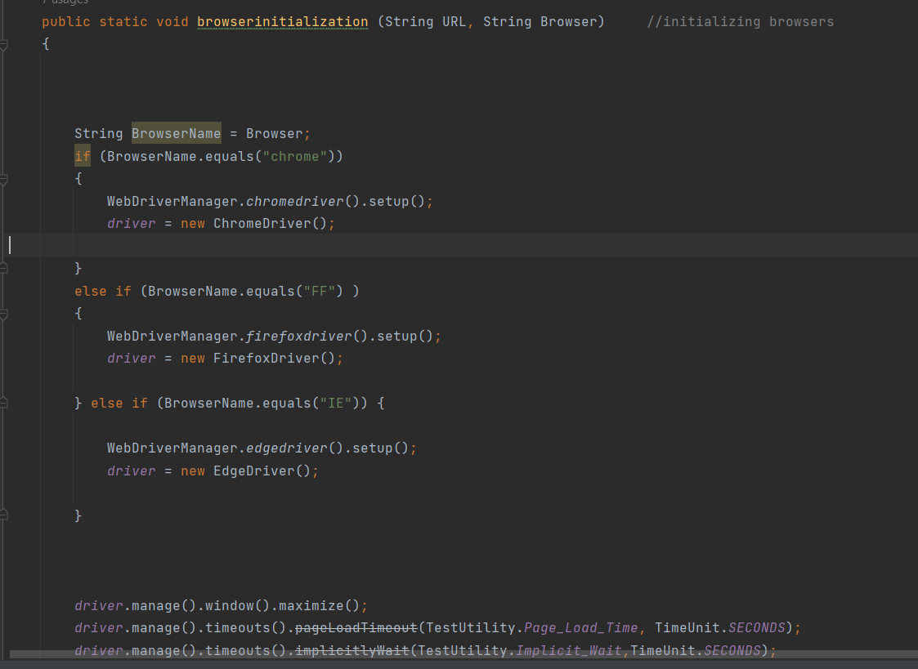

BasePage class code to initialize Browser according to the data in excel sheet.

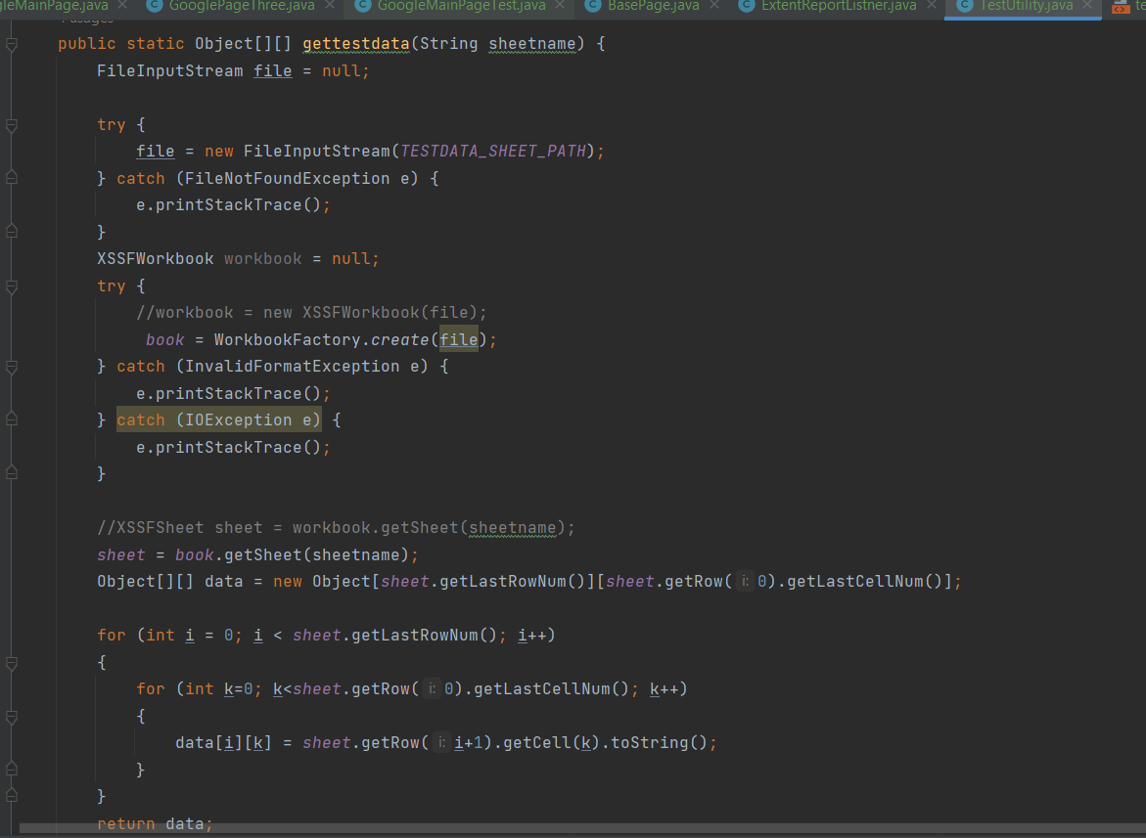

Test Utility class code used to extract data from excel sheet to be used in test cases .

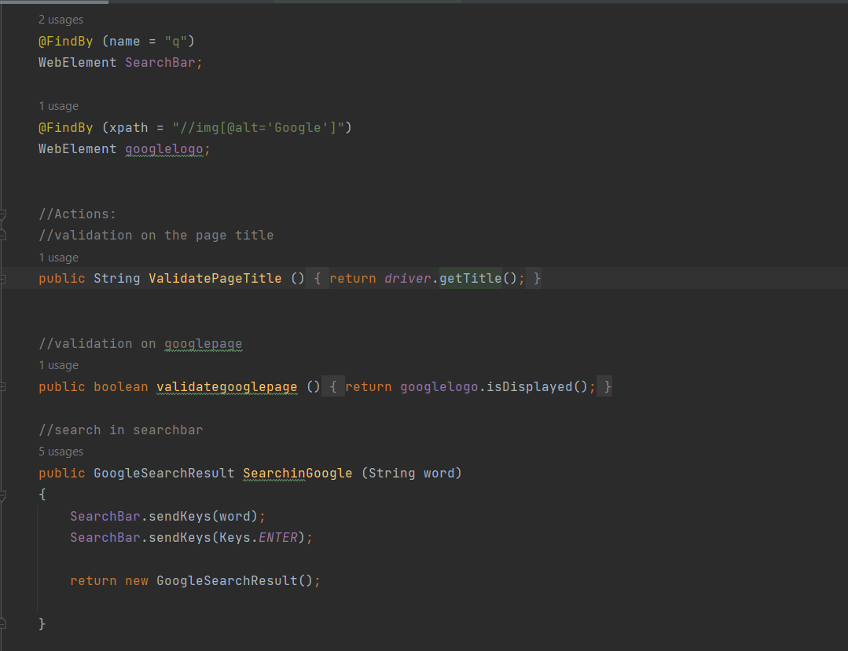

Google main page class contains methods to validate google page, and findby annotations are used from selenium framework .

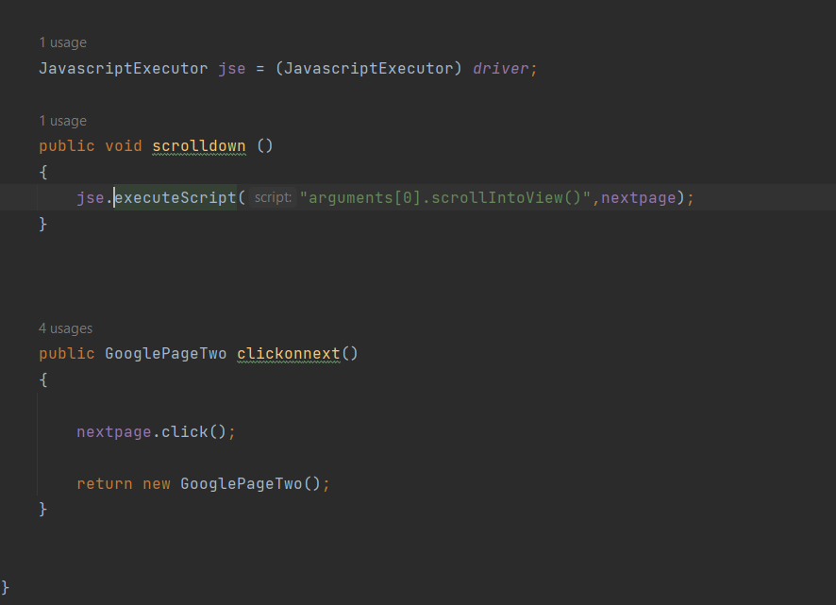

Result page to click on next page and scroll down .

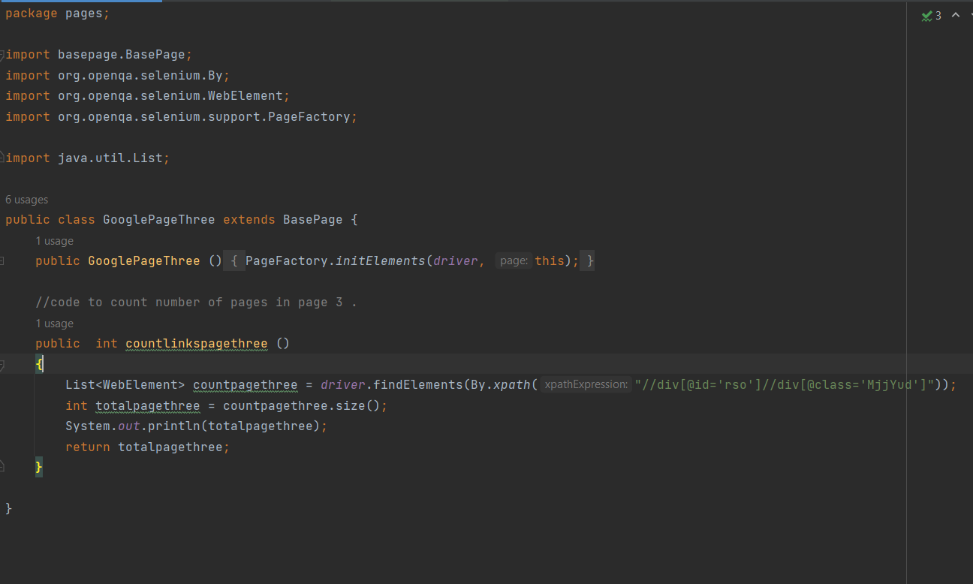

Page three class to count the results in page using dynamic xpath from selenium framework .

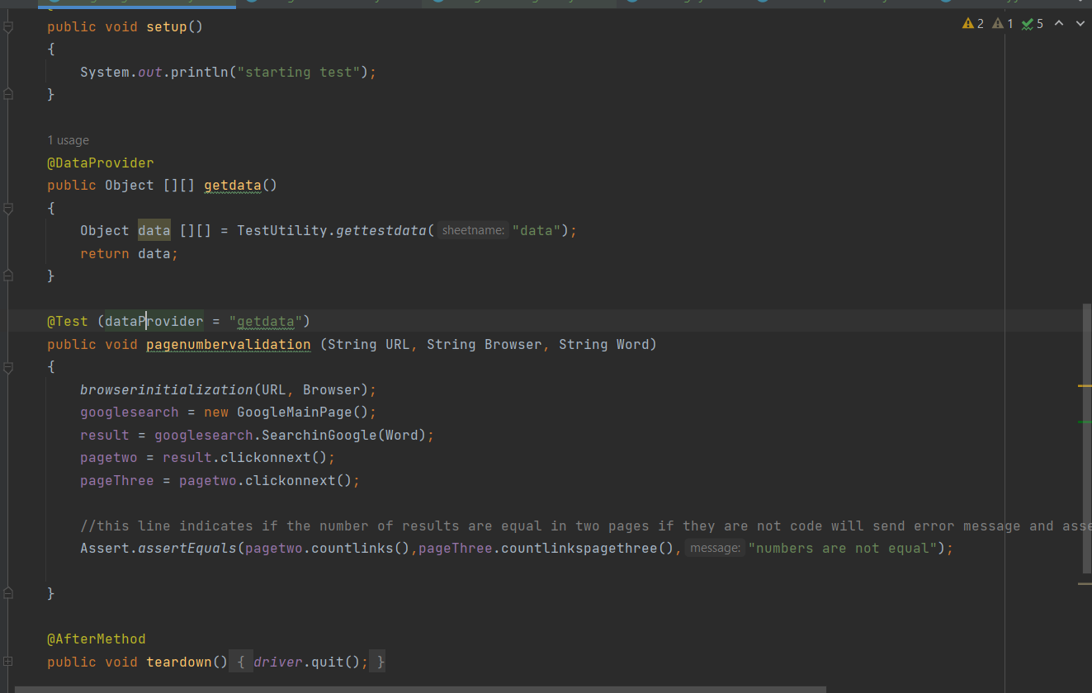

Test case for page three class to compare between result for page two and three using assertion .

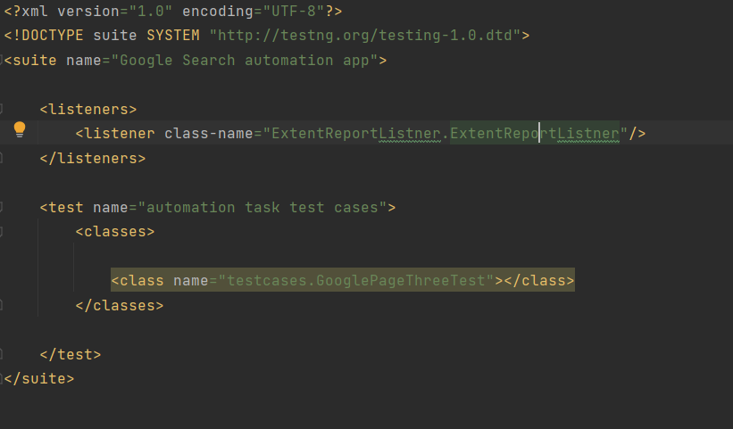

xml file used to run the test cases .

note :- kindly note I implemented each test case alone for it’s task and GooglePageThreeTest conations all the test cases as the project is hierarchy and each page is depending on the other page .

if you need to run one of then we can use the class in xml file .

**THANK YOU**